Name: AB Jallah Balyemah

Student ID#: LY2021041

Course: Computer Architecture

Assignment: Matrix Multiplication and record the execution time

Matrix Size:2000×2000

Six loop orders:

i-j-k

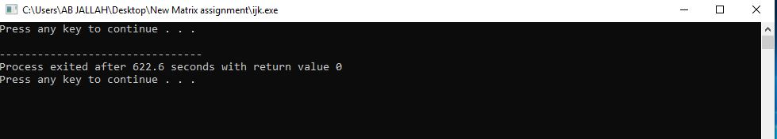Executed time: 622.6 seconds

i-k-j

Executed time: 131.9 seconds

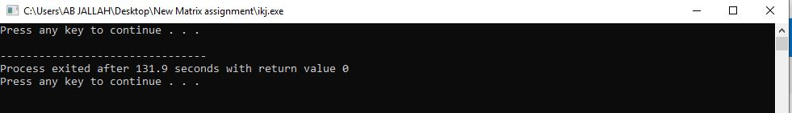

j-i-k

Executed time: 85.58 seconds

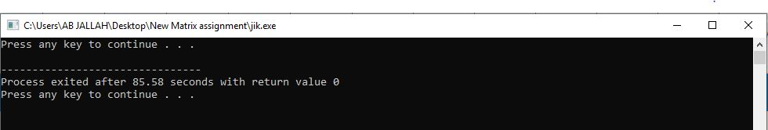

j-k-i

Executed time: 227.4 seconds

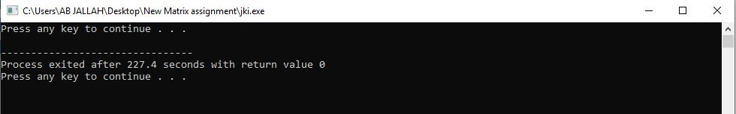

k-i-j

Executed time: 42.37 seconds

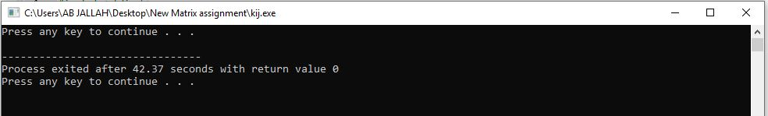

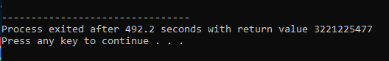k-j-i